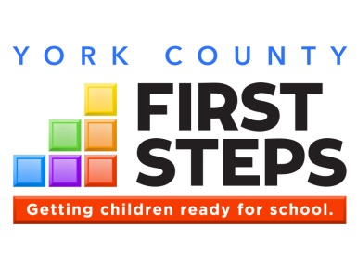

York County First Steps Partnership Board
Monthly Board Meeting
August 14, 2017

AGENDA

I. Call to Order/Invocation

II. Welcome

III. Minutes & Approvals – May 8, 2017

IV. Executive Director’s Update

V. Current Topics/Decisions
- NFP Status
  - J. Marion Sims Meetings
  - Enrollment Status

- Countdown to Kindergarten Summary
- Upcoming Elections – October 9, 2017
- Board Members
- Officers

VII. 5 Group Positive Observations

VIII. Adjournment

The mission of the York County
First Steps Partnership Board is to assist children, birth to six and their families by supporting collaborative efforts that ensure all children are prepared to succeed in school.

This meeting is being held within FOIA and ADA compliance. Persons with special needs should contact Susan Hagood at (803) 981-5780 to make necessary arrangements.

