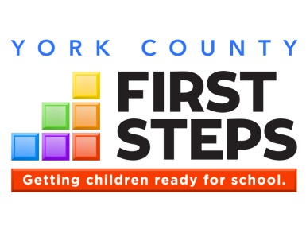

York County First Steps Partnership Board
Monthly Board Meeting
October 16, 2017

AGENDA

I. Call to Order/Invocation

II. Welcome

III. Minutes & Approvals – August 14, 2017

IV. Executive Director’s Update

V. Current Topics/Decisions
- NFP Status
  - J. Marion Sims Meeting Update
  - Enrollment Status

- Board Elections – October 9, 2017
- Board Members
- Officers
- Approval of Action Plan for Conditional Approval Items

VI. 5 Group Positive Observations

VII. Adjournment

The mission of the York County
First Steps Partnership Board is to assist children, birth to six and their families by supporting collaborative efforts that ensure all children are prepared to succeed in school.

This meeting is being held within FOIA and ADA compliance. Persons with special needs should contact Susan Hagood at (803) 981-5780 to make necessary arrangements.

