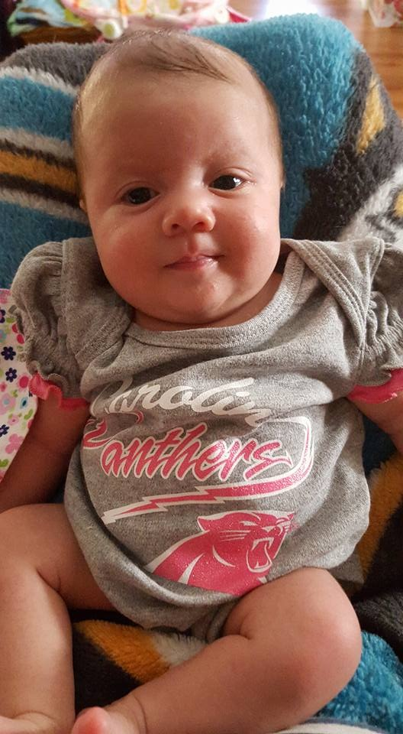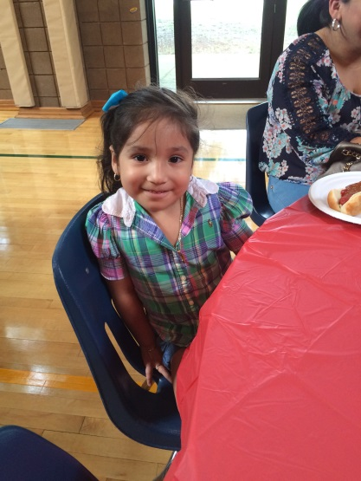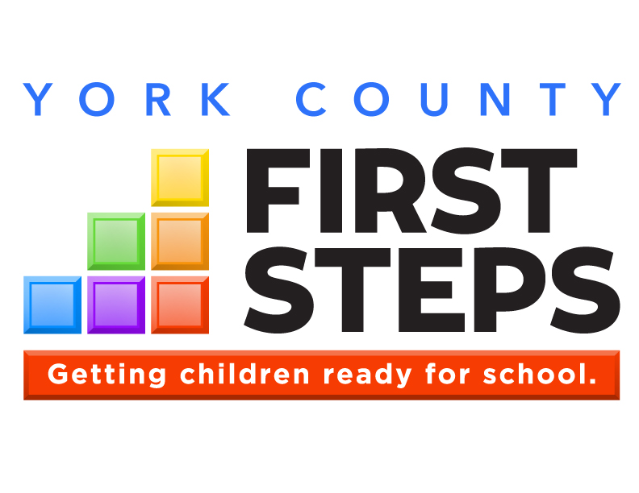

**OUR VISION:**

**Every South Carolina child will arrive at kindergarten   
ready to succeed.**

Annual Report

2014-15

**Parents as Teachers**

**Countdown to Kindergarten**

**Child Care Quality Enhancement**

**Child Care Training**

**Child Care Scholarships**

**Nurse-Family Partnership (Coming Soon!)**

**First Steps WORKS for the children of York County.**

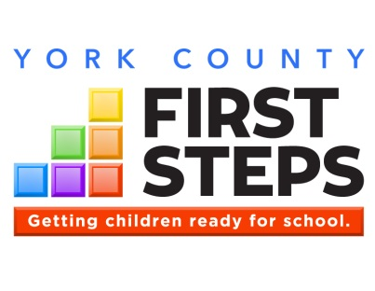

**A Message from our Most Important Shareholders**

Annual Report

2014-15

**Who We Serve**

**First Steps serves South Carolina’s young children and their families, with the goal of ensuring each is prepared for school success.**

**Number of York County children under 5:**

**15,344**

**Number of York County children under 5 living in poverty:**

**2,639**

**Babies born each year in York County to a mother with less than a high school diploma:**

**1 in 8**

**Our Programs**

**Parents as Teachers**

**Countdown to Kindergarten**

**Child Care Quality Enhancement**

**Child Care Training**

**Child Care Scholarships**

**Our Results**

* **We provided 823 home visits to 51 families through Parents as Teachers to help parents be more effective.**
* **We provided child care vouchers to 15 teen mothers as they stayed in school working to complete their high school degree.**

What are you going to do to help make our future great?

Board Chair  
Cindy Hunt

Executive Director  
David W. Lisk, Sr.

410 East Black Street

Rock Hill, SC 29731

(803)-981-5783

dlisk@rhmail.org

**www.YCFirstSteps.com**



Most annual reports are written for a rather narrow audience. Typically they are written for stockholders, or potential stockholders, of the company providing the annual report. Included are an abundance of numbers, a list of accomplishments, explanations, (if the financials are less than expected), and a vision of how things will improve next year. Our annual report is a bit like the typical annual report, there are financial summaries and lists of our accomplishments this past year; however, in my view, this is where the similarities end. As a public/private partnership responsible to coordinate programs and interventions for at risk preschool children, we have a much more diverse audience interested in how we “performed” last year.

Our Audience of Shareholders

Our efforts have a broad appeal within the community and garner interest in how well we are serving the at risk families that need our attention. The interested parties include our State Legislators, local civic and business leaders, our partner agencies and organizations, and most importantly, our children and their families that need help being prepared for success when they enter school. As much as I would have liked to design a single message for each of our constituents, I just don’t seem to be that creative. However, the more I thought about it the more I realized that it isn’t my message that needs to be heard but the message of the children we serve in our community. So let me help deliver their message to each group from the most important shareholder we have in common – our children!

As you read through our annual report, you will see how each of our interventions focused on serving the children’s needs in an effective way. Also, I hope that you see the message from our children to each of these groups that collectively hold the future of these children in their hands and as you read the messages, you reaffirm the group of which you are a part and recommit to fulfilling your role in their future success.

David W. Lisk, Sr.

Executive Director

[**www.yourwebsite.org**](http://www.yourwebsite.org)

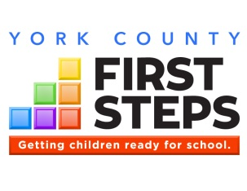

**Each of the six color blocks of the First Steps logo represents a core area of service, outlining our comprehensive strategy to prepare children for long-term school success.**

**With measurable outcomes across each of its six school readiness strategy areas, First Steps is getting results.**

What We Do

 **Healthy Start**

We begin with a focus on providing a healthy start to life. This includes prenatal and post-partum services for both mother and baby. In 2007, First Steps collaborated with key philanthropic and agency partners to bring Nurse-Family Partnership to SC having a significant impact on reducing premature births and Medicaid costs.

 **Family Strengthening**

Our home visitation strategies, such as Parents as

Teachers, Parent-Child Home and Early Steps to

School Success, are helping parents understand their responsibilities to care for and be positive models for their children. As a result of First Steps’ intervention and parenting support, 66% of clients initially assessed at “low” levels of parenting have achieved moderate or high levels of parenting skill.

 **Early Intervention**

According to recent federal evaluations, outcomes for clients participating in BabyNet early intervention programs are above national averages. BabyNet matches the special needs of infants and toddlers who have disabilities and/or developmental delays with customized, community-based resources.

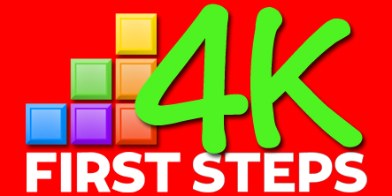

Interested parents can contact any participating 4K providers to complete an application. To view a list of participating First Steps 4K providers, visit:

**http://scfirststeps.org/4k**

 **Quality Childcare**

Quality childcare starts with quality childcare providers. Our quality enhancement and training strategies lead to improved teacher-student interaction, which research shows has a significant impact on a child’s development and success in school.

 **Early Education**

Private-public partnerships through First Steps 4K have led to significant cost efficiencies in the delivery of publicly funded 4K. One recent analysis suggests First Steps is achieving comparable results, without the need for costly capital construction, for 80 cents on the dollar.

 **School Transition**

Each of the corresponding blocks of services leads ultimately to the goal of transitioning children successfully to school. Programs like Countdown to Kindergarten and From Day One to Grade One are ultimately preparing children for school success.



**Based on the needs of our community, York County First Steps focuses its strategic investments in the following areas: Healthy Start, Family Strengthening, Quality Childcare and School Transition.**

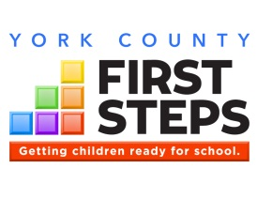

Parents as Teachers

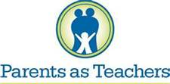

# Program Description

*“The best part of the program for me as a parent was the specific tools that were given to me to work with Jake each day…”*

Rhonda, Clover SD Parent

**Parents play a critical role in their child’s development.**

Parents as Teachers (PAT) is an evidence-based home visiting program designed to build strong communities, thriving families and children who are healthy, safe and ready to succeed. PAT services include:

1. **Personal Visits** at least twice monthly
2. **Monthly Group Connections** with other PAT families
3. **Screenings and Assessments** to identify developmental concerns
4. **Connections to Outside Resources** that families may need to succeed

**York County First Steps serves families in greatest need. Among our PAT families:**

|  |  |
| --- | --- |
| 96% | **… live in poverty** |
| 75% | **… didn’t graduate from high school** |
| 29% | **… were teen parents** |

# PAT by the Numbers 2014-15

|  |  |  |
| --- | --- | --- |
| Families Served | 51 | |
| Children Served | 51 | |
| Total Home Visits | 823 | |
| Hours Spent Serving Families | 1334 | |
| Average gain, *Keys to Interactive Parenting Scale* (pre-to-post): | KIPS - .52 | ACIRI -A- .17  C- .29 |

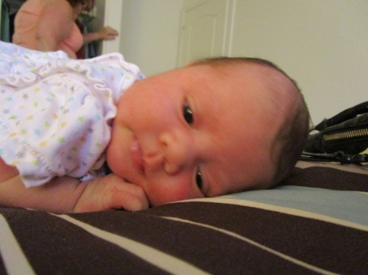

**My parents look forward to our home visits!**

### York County First Steps

410 East Black Street

Rock Hill, SC 29731

803-981-5780

[dlisk@rhmail.org](mailto:dlisk@rhmail.org) www.YCFirstSteps.com

**This year, our Parents as Teachers program:**

* **Averaged 2.0 home visits per family across the County for the 51 families we served with Parents as Teachers**
* **Identified and addressed 18 potential developmental delays**
* **Made 101 connections for families to services such as Child Care Vouchers, BabyNet, and Medical Services**
* **Improved literacy skills in the community through several initiatives in partnership with Rock Hill Reads, the School Districts, The Early Learning Partnership and others to distribute over 2000 books to at risk children. Special Reading Centers were conducted in Clover and Fort Mill during the summer to help children develop needed pre-literacy skills.**

**Parenting Partners and York SD #1**

**Bright Beginnings and Clover SD #2**

**ParentSmart and Rock Hill SD #3**

# Thank you to our partners!

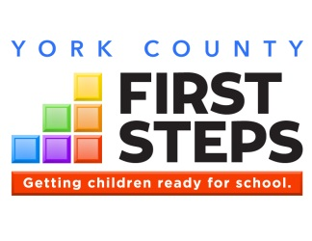

Child Care Quality Enhancement

**Children’s reading scores improve dramatically when parents are involved   
in helping them learn to read.**

# QE by the Numbers, 2014-15

|  |  |
| --- | --- |
| Child Care Providers Served | 12 |
| Number of TA Visits Provided | 236 |
| Number of Children 0-5 Enrolled in Provider Classrooms | 750 |

# Program Description

### York County First Steps

410 East Black Street

Rock Hill, SC 29731

803-981-5780

[dlisk@rhmail.org](mailto:dlisk@rhmail.org) www.YCFirstSteps.com

**This year, our Quality Enhancement program:**

* **Improved quality, on average, by .875 based on pre/post Environment Rating Scale assessments for the 12 Child Care Providers in our QE Strategy**
* **Provided 561.5 hours of technical assistance to child care providers**
* **Provided $15,000 in materials grants to participating child care providers**
* **Funded scholarships for 7 children within participating child care providers**

***Congratulations to our QE participants for 2014-15!***

|  |  |
| --- | --- |
| **Child Care Provider** | **Pre/Post Improvement** |
| Agape CDC | +1.23 |
| Kid’s Academy | +1.18 |
| Londyn Bridges | +1.15 |
| I Montessori | +1.11 |
| House of Joy | +.98 |

The quality of care they received by young children is crucial to their healthy development and school readiness. Child care providers strive to provide high quality care, but may lack the resources that are commonly available to publicly-funded early childhood programs, such as educational materials, on-site professional development, and other support.

**First Steps’ Child Care Quality Enhancement (QE) is intended to produce measurable improvements in the quality of care provided to young children.** Participating child care providers must serve a high percentage of at-risk children, and are selected through a competitive process that requires a strong level of commitment to the QE process.

Program Components

1. On-site Technical Assistance (TA) at least twice monthly
2. Equipment and materials funding
3. Integration with locally available training, provided by First Steps and other partners
4. Workforce Development
5. Coordination with community partners
6. Pre/post assessments of the classroom environment and teacher-child interaction, using nationally-recognized observational tools for infant/toddler and preschool settings (ITERS,ECERS,FCCERS)

# *Thank you to our partners!*

**Kaplan**

**Children’s Museum of York County**

**York County Network of Child Care Providers**



**Those who care for young children need high-quality, accessible, and affordable professional development.**

Child Care Training

**This year, our Training program provided:**

* **305 early childhood staff with high quality training**
* **70.5 hours of certified training was provided for staff to meet annual re-certification requirements**
* **187 child care professionals from York and surrounding Counties with 5 hours of certified training as part of our Early Childhood conference.**

**Wow! That was a lot of information.**

**Child Care Training Sponsored by   
York County First Steps, 2014-15**

Topic: Sessions:

Forgotten Centers Two Session (1 w/ LCFS)

Preparing for Emergencies Two Session (1 w/ LCFS)

Blood-Borne Pathogens One Session

Program Administration One Session

Playground Adventures Two Session (1 w/ LCFS)

Power of Reflection One Session w/ LCFS

# Training by the Numbers, 2014-15

|  |  |
| --- | --- |
| Total Training Attendance | 305 |
| Child Care Teachers and Directors Served | 25 |
| Number of Training Sessions Offered | 17 |

**Dutchman Creek Middle School and the Rock Hill SD**

**Kaplan**

**Winthrop University**

**York Technical College**

**CCCC&D**

# *Thank you to our partners!*

### York County First Steps

410 East Black Street

Rock Hill, SC 29731

803-981-5780

[dlisk@rhmail.org](mailto:dlisk@rhmail.org) www.YCFirstSteps.com

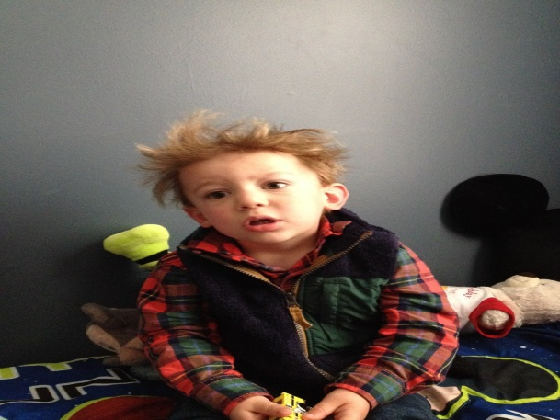

High-quality child care hinges on high-quality professional development that meets the needs of the local child care workforce.

First Steps-sponsored training is certified through the SC Center for Child Care Career Development and includes topics in the areas of nutrition, health and safety, curriculum, child guidance, professional development and program administration. Best practices in training include not only the training itself, but follow-up in the classroom.

# Program Description

***The sessions were great and very informative; I can’t wait to work with my children next week!***

Martha, Conference Attendee



Child Care Scholarships

**Too many families in York County cannot afford quality care for their children.**

# Program Description

**Mommy studies hard for both of us!**

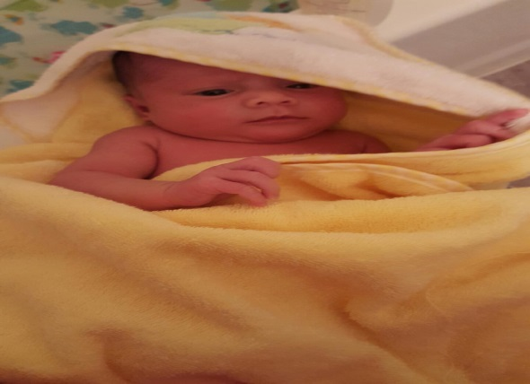

**This year, our Scholarship program:**

* **Provided 15 children with scholarship assistance so their mother could attend school**
* **Supported 7 small businesses in York County by subsidizing child care tuition for families who would not otherwise be able to afford quality care**
* **Provided full Parents as Teachers services to all Teen Mothers receiving Child Care Scholarship Vouchers**
* **80% of the teen mothers we served graduated from high school or continued in the program into their senior year**
* **Received tuition discounts from the local child care providers to help fund additional opportunities for more teen mothers**

### York County First Steps

410 East Black Street

Rock Hill, SC 29731

803-981-5780

[dlisk@rhmail.org](mailto:dlisk@rhmail.org) www.YCFirstSteps.com

# *Thank you to our partners!*

**York, Clover, Rock Hill and Fort Mill School Districts**

**Local Childcare Providers**

**Access to quality child care is essential for children while away from their primary caregivers.** Yet, of those families income-eligible for child care assistance in South Carolina, only a small fraction receive it due to lack of funds. In the absence of nurturing and consistently available family, friends or neighbors, parents are faced with few - or no – affordable care options.

**York County First Steps serves families in greatest need. Among our scholarship families:**

|  |  |
| --- | --- |
| 100% | **… live in poverty** |
| 100% | **… didn’t graduate from high school** |
| 100% | **… were teen parents** |
| 80% | **… graduated from high school this year.** |

In addition to regular monitoring of child care providers that receive First Steps scholarships, First Steps conducts at least one developmental screening each year with scholarship children and connects families to needed services within the community.

Each of our teen parents receiving a child care voucher is still in school working hard to complete their degree while adjusting to the responsibilities of being a first time mother. To assist in this balance between parent and student, each mother is assigned a Parent Educator from their school district and receives PAT services.

# Scholarships by the Numbers, 2014-15

|  |  |
| --- | --- |
| Children Served | 15 |
| Providers Served | 7 |

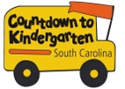

# *CTK by the Numbers, Summer 2014

|  |  |
| --- | --- |
| Children Served | 161 |
| Families Served | 159 |
| Home/School Visits | 902 |

# *\*CTK program data is for June-August 2014, whereas CTK fiscal data includes expenditures from July 1, 2014 through June 30, 2015.*

Countdown to Kindergarten (CTK) is a summer home visitation model connecting rising kindergartners and their families with their future teachers. The program is designed:

* to forge strong and lasting home-school relationships,
* to acquaint children and families with the state and classroom expectations to increase the likelihood of school success,
* to increase parent involvement in the early grades (particularly in hard-to-reach communities), when children’s learning is foundational for life success; and
* to increase public awareness of the importance of school readiness and provide ways for parents and communities to impact children’s early school success.

Countdown to Kindergarten integrates all of the following:

**Home Visitation.** Teachers make six visits over the summer to the homes of participating students and families. Children and families are introduced to actual materials used in kindergarten and are given a Kindergarten Transition Toolkit to keep.

**Learning Celebration.** The last visit is a “field trip” to the school where the child will attend class in the fall.

**Public Awareness.** Throughout the summer, First Steps releases tips to media to help parents and caregivers get children ready for kindergarten.

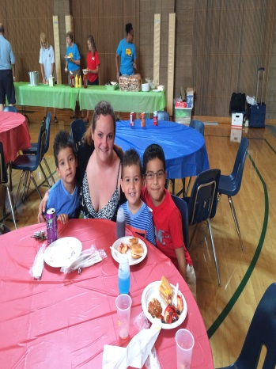

***“I am so grateful for the opportunity of helping my son have the best possible start for 5K. This is an amazing program!”***

Juanita, York SD 1 Parent

Countdown to Kindergarten

**Bringing parents and teachers together as partners sets the foundation for success in school.**

**This year, our Countdown to Kindergarten program:**

* **71% of the parents increased the amount of time they read to their child during the summer they were enrolled in the CTK Program**
* **We helped sponsor a county wide Kindergarten Celebration for all rising kindergarten students and their families with the Children’s Museum and 30 other local organizations and service providers. Attendance for the event was between 1200 and 1500. Our booth, “Ask a Kindergarten Teacher” and a School Bus were popular attractions.**
* **Local donations from local businesses and our Board Members allowed us to provide school supplies, books, and dinner for our CTK children and their families**

### York County First Steps

410 East Black Street

Rock Hill, SC 29731

803-981-5780

[dlisk@rhmail.org](mailto:dlisk@rhmail.org) www.YCFirstSteps.com

# Program Description

**The risk factor box underneath is a Table. To add or delete lines, you must Insert or Delete Rows by right-clicking on the appropriate line. This applies to all pages that include a risk factor box.**

**Use data from the Risk Factor Report to find the most compelling statistics for your program.**

**Delete this text box.**

**York, Clover, Rock Hill, and Fort Mill School Districts**

**Children’s Museum**

**Sisters of Mercy NC Foundation**

**United Way of York County**

# *Thank you to our partners!*

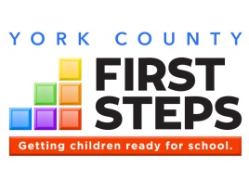

Financial Impact

**Total 2014-15 Expenditures: $711,221**

**State Funds Leveraged in 2014-15*: 69%**

**\*Percentage of state dollars matched by additional federal, private, and/or in-kind funds**



**Since inception, York County First Steps has leveraged $4,547,487 from sources outside of state government. That’s 74 cents for every state dollar.**

*Unaudited numbers for the period July 1, 2014 through June 30, 2015*

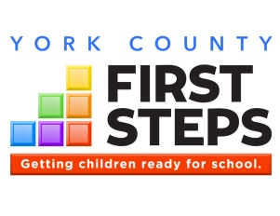

**A message from our children:**

The Future is in your hands

Annual Report Message

**Support York County First Steps today through a tax-deductible donation, or volunteer.**

**To our State Legislators** - In our most recent legislative session there was a great deal of focus placed on early childhood priorities. Certainly a number of pressing issues in SC exist and it is always a great sign when early childhood issues receive the needed attention they deserve. The one message I believe our children would want our legislators to hear is – The most effective help that you can provide in the upcoming session is to continue the priority discussion of early childhood interventions. Continue to help everyone within the great State of SC understand how important it is for all agencies and organizations to work together to provide the most comprehensive services for our families. We are the future of SC.

**To our Civic and Business Leaders** – The children’s message would be - Our families are an integral part of the community that we share. Help us to grow up and help our community be even stronger. We have great potential and with your support of our families and guidance for our future, your investment will pay huge dividends. There is a critical role that you can be involved in our lives because we will soon be your employees, neighbors, and customers.

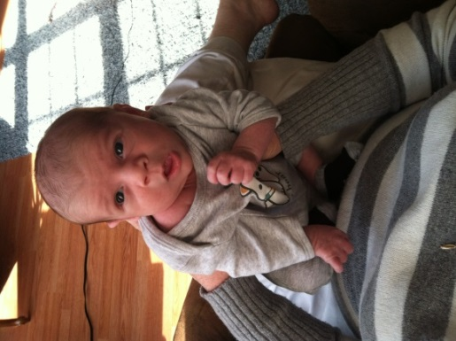**To the State Agencies and Organizations** – SC children’s message is - We appreciate the passion and commitment that you bring to your career each day. Sometimes our families become frustrated with the pace of progress; however, we know that you care and wish for us the best in life. You may become frustrated with our families as they struggle to balance all the complexities of life. We ask that you continue to be patient and guide our families in a path that helps us thrive.

**To our Parents** – The children say - We know that life can be very difficult as you try to provide us with a safe home that meets all our needs. We know that you love us and wish for us to have everything in the world; but please realize that the most important thing that we need, is your time and attention. Read with us, talk with us, be encouraging to us as we prepare to enter school. You have the most important role in our lives and we want you to be actively involved as we work to realize our dreams.

**I am using my words!**

Listen to our Children!

# Thank you to our partners!

**In-Kind Support**

York SD #1

Clover SD #2

Rock Hill SD #3

Fort Mill SD #4

Children’s Museum of York County

The Early Learning Partnership

**Funding Support**

State of South Carolina: $420,108  
(*through South Carolina First Steps*)

United Way of York County: $15,000

Sisters of Mercy NC Foundation: $23,250

YCFS Board Members: $2275

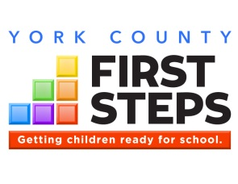

Community Impact

**Community Comes Together to Celebrate Kindergarten**

**Countdown to Kindergarten continues to grow in the Community**

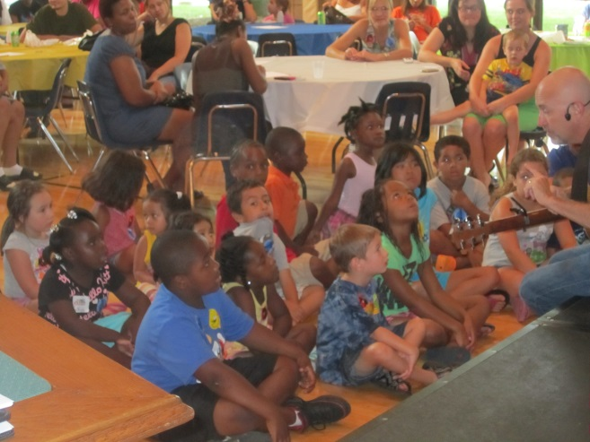

The Countdown to Kindergarten (CTK) Program continues to grow within the County as our community collaborations grow. 2015 was our third year partnering with the Children’s Museum of York County to help sponsor the CTK County wide Celebration in downtown Rock Hill. YCFS with all four School Districts served 160 rising kindergarten children that could benefit from the CTK Program. CTK helps the children develop the needed skills to be successful in school and help their parents understand the vital role they play in their child’s educational journey.

School Supplies, Books and Dinner provided by the Board and our Partners!

Roger Day is the Pied Piper for CTK Children!

We worked with school district teachers to help each family prepare for kindergarten with home visits during the summer. During our Celebration we provide every child with school supplies, they select a book to take home, and we provide dinner for each child and their family before heading to the County wide festivities. The school supplies, dinner, and books are all provided through donations from our Board Members and Community Partners.

Importance of starting a journey fully prepared

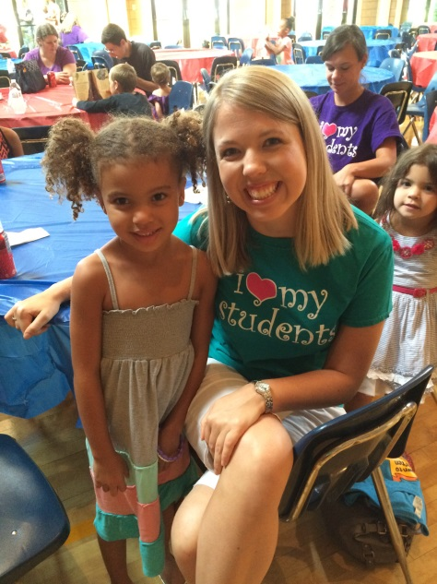Can you imgine starting a long journey without making the needed preparations for such a trip? I used to travel quite a bit earlier in my career and I was always in preparation for trips. Reports needed to be completed, appointments had to be made, travel arrangements required finalization and I also needed to insure things at home were taken care of until I returned. The children entering Kindergarten are starting a journey, an educational journey. Just like with a buiness trip, preparation is key to making the journey a success. Unfortunately, many of the children in our community are not prepared for the journey when they arrive at school. Countdown to Kindergarten is one of our interventions designed to help children not quite prepared for one of the most important journeys in life. The possibilities are limitless when we scan the future prospects for children born today. Our partners assisting our efforts in our programs, such as Countdown to Kindergarten, collaborate with the goal to pool our collective resources, skills, experiences, and yes our hopes and dreams for a better community for all. We will continue to perservere in our mission to help every child enter school fully prepared to be successful and we look forward to working with you, our State and Community Leaders and neighbors to “perform” better each and every year.

**There is a special bond with your first teacher!**

**Support York County First Steps today through a tax-deductible donation, or volunteer.**



**York County Board Tackles Nurse-Family Partnership**

Flexibility is always a plus!

First Steps Partnership Board

This past year the York County First Steps Partnership Board faced several challenging hurdles to develop a suitable path forward for bringing Nurse-Family Partnership to our community. For several years our community attempted to engage an Implementing Agency to provide Nurse-Family Partnership services to at risk first time mothers in our Region. Meetings in the community studied possible organizations as a possible Implementing Agency and after several options were considered, York County First Steps took the challenge to apply. Tackling this program as the Implementing Agency will transform not only the overall YCFS profile but also add to our capability to accomplish our mission. The Board accepted the opportunity and over the next several months made the following decisions in support of the NFP Program and making NFP a reality:

* Voted to apply to the National Service Office of NFP to be the Implementing Agency for Chester, Lancaster, and York County. A tremendous community support network was developed as part of the application process.
* After receiving approval by NFP and subsequently learning we were not covered by the State NFP expansion plans, the Board voted to proceed by redirecting a portion of our yearly budget for the next 3 years and to seek additional funders.

|  |  |  |
| --- | --- | --- |
| **Name** | **Position** | **Board Category** |
| **Cindy Hunt, Chair** | **ParentSmart Family Resource Center** | **Appointee – Rock Hill SD #3** |
| **Carol Mann, Vice Chair** | **Retired School Teacher** | **Appointee - Legislative** |
| **Deborah Dukes, Secretary** | **York Technical College Professor** | **Family Education** |
| **Vivian Agurs** | **Smart Kids CDC** | **Faith Community** |
| **Joyce Argo** | **Teacher at Clinton Elementary School** | **Pre-K – Primary School** |
| **Mary Chamberlain** | **Winthrop Makefast CDC** | **Early Childhood Education** |
| **Nina Feemster** | **Bright Beginnings Family Resource Center** | **Appointee – Clover SD #2** |
| **Susan Collier** | **DHEC** | **Appointee - DHEC** |
| **Twila Koss** | **Little Fox CDC** | **Business** |
| **Debby Miller** | **DSS** | **Appointee - DSS** |
| **Linnie Miller** | **Carolina Community Action – HeadStart** | **Nonprofit** |
| **Penny Sanders** | **Parenting Partners Family Resource Center** | **Appointee – York SD #1** |
| **Mary Watson** | **Winthrop MacFeat CDC** | **Pre-K Primary School** |
| **Diane Williams** | **York County Library** | **Appointee – York County Library** |
| **Beth Cooper** | **Culture and Heritage Museum – Children’s Museum** | **Nonprofit** |
| **Joy Bower** | **Rock Hill School District** | **Medical** |
| **Lori Mitchell/Scott Gillelan** | **The Early Learning Partnership** | **Nonprofit** |
| **Carol Perkins** | **PITC** | **Early Education** |
| **Jane Culp** | **LEAP Ahead Family Resource Center** | **Appointee - Fort Mill SD #4** |
|  |  |  |
|  |  |  |
|  |  |  |
|  |  |  |

**York County First Steps Partnership Board, 2014-15**

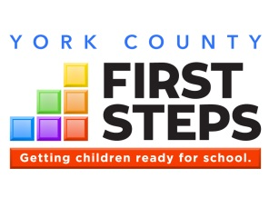

# The Goals of First Steps

Getting children ready for school.

**(1) provide parents with access to the support they might seek and want** to strengthen their families and to promote the optimal development of their preschool children;

**(2)increase comprehensive services** so children have reduced risk for major physical, developmental, and learning problems;

**(3)promote high‑quality preschool programs** that provide a healthy environment that will promote normal growth and development;

**(4)provide services** so all children receive the protection, nutrition, and health care needed to thrive in the early years of life so they arrive at school ready to succeed; and

**(5)mobilize communities** to focus efforts on providing enhanced services to support families and their young children so as to enable every child to reach school healthy and ready to succeed.

-- Section 59‑152‑30



BabyNet in York County:   
803-222-5360

**http://scfirststeps.org/babynet/**



Interested parents can contact any participating 4K providers to complete an application. To view a list of participating First Steps 4K providers, visit:

**http://scfirststeps.org/4k**

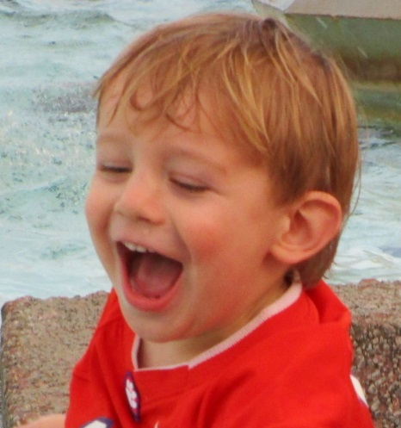

I am soooo happy that you support the children of York County! Thank you!

**Support York County First Steps today through a tax-deductible donation, or volunteer!**