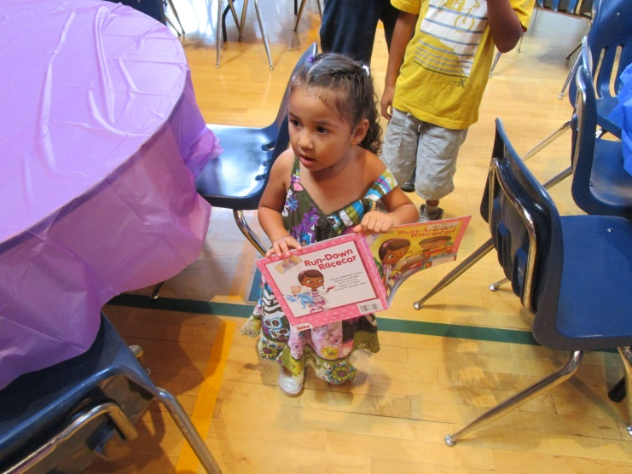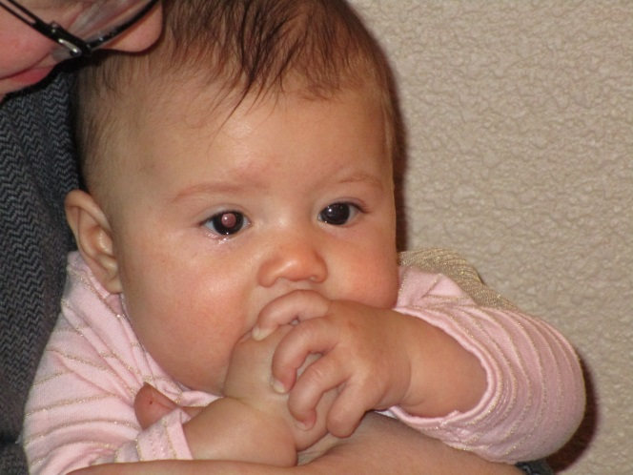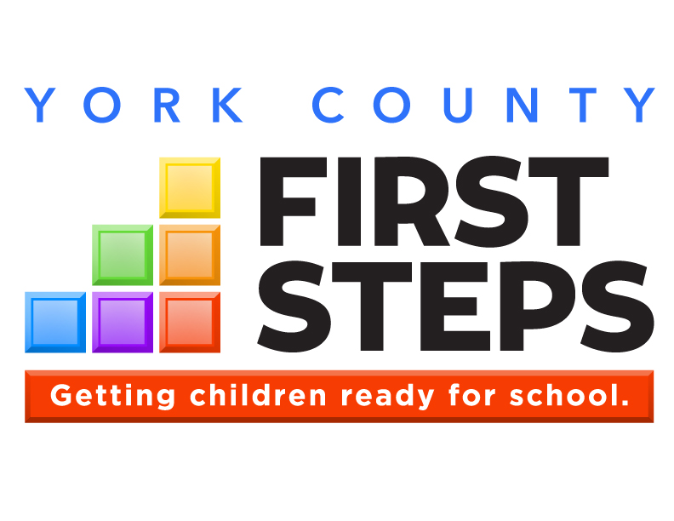

**OUR VISION:**

**Every South Carolina child will arrive at kindergarten   
ready to succeed.**

Annual Report

2015-16

**Parents as Teachers**

**Countdown to Kindergarten**

**Child Care Quality Enhancement**

**Child Care Training**

**Child Care Scholarships**

**Nurse-Family Partnership**

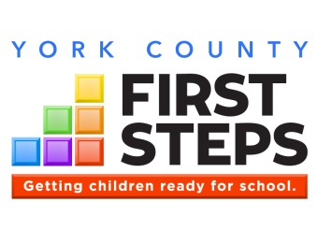

New Program to Expand our Services

I recently ran across an interesting quote from Dr. Alicia Lieberman of the Child Trauma Research Program of the University of California in San Francisco, “Often, the circumstances of a mother’s life overwhelm her natural coping capacity. When you are bombarded by poverty, uncertainty, and fear, it takes a superhuman quality to provide conditions for a secure attachment.” Research has shown that the positive attachment that forms between very young children and their parents has a direct and long lasting influence on how well the child will perform in school and function as an adult. Programs that foster parents developing positive attachments with their children are regarded as the most effective early childhood intervention strategies and this is where we see our most effective areas to expand services.

During this past year, a great deal of our effort was spent to lay the needed groundwork to bring the Nurse-Family Partnership Program to fruition. NFP will provide a significant expansion of our services for the very youngest children being born into vulnerable circumstances. The program enrolls at risk first time mothers prior to their 6th month of pregnancy and provides home visits until the child reaches two years old. One of the objectives of the program is to assist mothers in forming positive attachments with their newborn child. During this past year, we secured the needed funding to hire our Program Manager and our initial two Home Visitation Nurses. Our plan is to collaborate with our community partners to enroll first time at risk mothers in early fall of 2016. Long-term plans are to expand to provide the same services to Chester and Lancaster Counties along with all of York County with six additional nurses.

The NFP Program provides a key expansion to our interventions for vulnerable children and their families. The compliment with our existing programs will provide a comprehensive array of interventions and offer “soft landings” for families as they exit from one program but still may need early services. Our focus continues to be helping families form positive attachments that prepare their children for success.

David W. Lisk, Sr.

Executive Director

YORK COUNTY

**By The Numbers**

|  |  |  |
| --- | --- | --- |
| **Indicator** | **SC** | **York County** |
| Children Under Five | 290,519 | 15,344 |
| Children In Poverty | 27.3% | 17.2% |
| 3rd Graders Below Standard in Reading | 21.1% | 17.9% |
| Births to Mothers With Less Than a High School Diploma | 15.7% | 12.2% |

[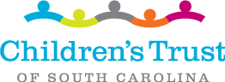](http://scchildren.org/?utm_source=Children's+Trust+News+-+August&utm_campaign=Children's+Trust+News+6-9-16&utm_medium=email)

**Highlights**

* Since inception, York County First Steps has leveraged $4,633,327 from sources outside state government. **That’s $.70 for every dollar received.**
* **868 hours of support and guidance** were provided to 47 families in our Parents as Teachers Program.
* **Childcare professionals received 346 hours** of technical assistance for early care best practices.
* **Provided 144 rising kindergarten children** with Countdown to Kindergarten services that provided 838 home and school visits.
* **Total Children Served in FY16:** 
  + **191 children and families with intensive home visitation programs.**
  + **912 children indirectly impacted by assisting their childcare professional with direct technical assistance and/or high quality training.**

York County First Steps

410 East Black Street  
Rock Hill, SC 29731

Phone: (803) 981-5780  
Fax: (803) 981-5784

Board Chair  
Cindy Hunt

chunt@rhmail.org

**www.YCFirstSteps.com**



Quality

Child Care



School

Transition



Early

Education



Family

Strengthening



Heathy

Start

**State Programs**

BabyNet

First Steps 4k

Early HeadStart

**County Programs**

Parents as Teachers

Nurse-Family Partnership

Quality Enhancement

Child Care Training

Countdown to Kindergarten

Childcare Vouchers

KIDS COUNT data provided by

[**www.yourwebsite.org**](http://www.yourwebsite.org)

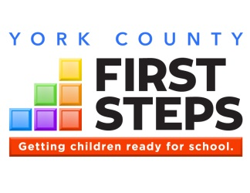

**Each of the six color blocks of the First Steps logo represents a core area of service, outlining our comprehensive strategy to prepare children for long-term school success.**

**With measurable outcomes across each of its six school readiness strategy areas, First Steps is getting results.**

What We Do

 **Healthy Start**

We begin with a focus on providing a healthy start to life. This includes prenatal and post-partum services for both mother and baby. In 2007, First Steps collaborated with key philanthropic and agency partners to bring Nurse-Family Partnership to SC having a significant impact on reducing premature births and Medicaid costs.

 **Family Strengthening**

Our home visitation strategies, such as Parents as

Teachers, Parent-Child Home and Early Steps to

School Success, are helping parents understand their responsibilities to care for and be positive models for their children. As a result of First Steps’ intervention and parenting support, 66% of clients initially assessed at “low” levels of parenting have achieved moderate or high levels of parenting skill.

 **Early Intervention**

According to recent federal evaluations, outcomes for clients participating in BabyNet early intervention programs are above national averages. BabyNet matches the special needs of infants and toddlers who have disabilities and/or developmental delays with customized, community-based resources.

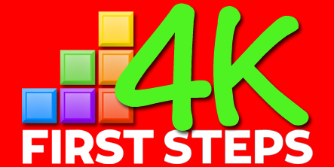

Interested parents can contact any participating 4K providers to complete an application. To view a list of participating First Steps 4K providers, visit:

**http://scfirststeps.org/4k**

 **Quality Childcare**

Quality childcare starts with quality childcare providers. Our quality enhancement and training strategies lead to improved teacher-student interaction, which research shows has a significant impact on a child’s development and success in school.

 **Early Education**

Private-public partnerships through First Steps 4K have led to significant cost efficiencies in the delivery of publicly funded 4K. One recent analysis suggests First Steps is achieving comparable results, without the need for costly capital construction, for 80 cents on the dollar.

 **School Transition**

Each of the corresponding blocks of services leads ultimately to the goal of transitioning children successfully to school. Programs like Countdown to Kindergarten and From Day One to Grade One are ultimately preparing children for school success.

**Based on the needs of our community, York County First Steps focuses its investments in all six categories working to build a solid foundation for our children to succeed when they enter school.**

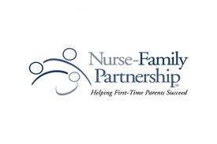

**Helping vulnerable first-time mothers empowers them to achieve a better life   
for themselves and their children.**

Nurse-Family Partnership

# Program Description

Learning begins prior to birth.

*The NFP Program has been studied in three separate randomized controlled trials, which have shown positive effects on the mothers, including reduced incidence of abuse, arrest, and welfare enrollment.*

Paul Tough from his 2016 Book Helping Children Succeed: What works and why, 2016

### York County First Steps

410 E. Black St., Rock Hill, SC 29731

Phone – (803) 981-5783

Email - dlisk@rhmail.org

Web Address - www.YCFirstSteps.com

Nurse-Family Partnership (NFP) helps transform the lives of vulnerable first-time mothers and their babies. Through ongoing home visits from registered nurses, low-income, first-time moms receive the care and support they need to have a healthy pregnancy, provide responsible and competent care for their children, and become more economically self-sufficient. From pregnancy until the child turns two years old, Nurse-Family Partnership Nurse Home Visitors form a much-needed, trusting relationship with the first-time moms, instilling confidence and empowering them to achieve a better life for their children – and themselves.

York County First Steps is the implementing agency for Nurse-Family Partnership in Chester, Lancaster, and York County.

**York County First Steps serves families in greatest need. Among our NFP families: Coming in FY 2017!**

|  |  |
| --- | --- |
|  | **… live in poverty** |
|  | **… graduate from high school** |
|  | **… are teenage mothers still in school** |

# NFP by the Numbers, 2015-16

|  |  |
| --- | --- |
| Children Served | To Start in FY 17 |
| Number of Home Visits | To Start in FY 17 |



**This year, our NFP program:**

* **Secured sufficient funding for the first 2-3 years of our Program**
* **Hired our NFP Program Manager and our first 2 Home Visitation Nurses**
* **All preparations were completed to allow at risk first time mothers to begin receiving services in early FY 17**

# *Thank you to our partners!*

**Sisters of Mercy NC Foundation**

**The Springs Close Foundation**

**The Winer Family Foundation**

**The United Way of York County**

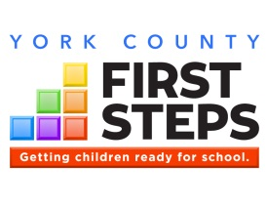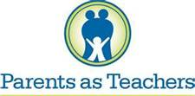

Parents as Teachers

# Program Description

*It has been wonderful to see my daughter get so excited about the lessons that we learn with each visit from our Parent Educator.*

Maria – PAT Parent

**Parents play a critical role in their child’s development.**

Parents as Teachers (PAT) is an evidence-based home visiting program designed to build strong communities, thriving families and children who are healthy, safe and ready to succeed. PAT services include:

1. **Personal Visits** at least twice monthly
2. **Monthly Group Connections** with other PAT families
3. **Screenings and Assessments** to identify developmental concerns
4. **Connections to Outside Resources** that families may need to succeed

**York County First Steps serves families in greatest need. Among our PAT families:**

|  |  |
| --- | --- |
| 91% | **… live in poverty** |
| 74% | **… didn’t graduate from high school** |
| 21% | **… were teen parents** |

# PAT by the Numbers 2015-16

|  |  |  |
| --- | --- | --- |
| Families Served | 47 | |
| Children Served | 47 | |
| Total Home Visits | 794 | |
| Hours Spent Serving Families | 1048 | |
| Average gain, *Keys to Interactive Parenting Scale* (pre-to-post): | KIPS- .20 | ACIRI –   1. .14   C -.35 |

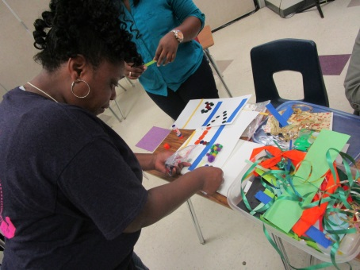

PAT parents eagerly want to learn new ways to interact with their children.

### York County First Steps

410 E. Black St., Rock Hill, SC 29731

Phone – (803) 981-5783

Email - dlisk@rhmail.org

Web Address - www.YCFirstSteps.com

**This year, our Parents as Teachers program:**

* **Averaged 1.93 home visits per family with an average duration of 1.09 hours**
* **Improved parenting practices through offering 108 group meetings with total attendance of 765**
* **Improved literacy through book distribution with our PAT Partners, the four York County School Districts, and The Early Leaning Partnership (DPIL) to distribute over 18,000 new and gently used books in York County.**
* **Made 103 connections, 87.3 % connection rate, for families to services such as Department of Social Services, Health Department, Affinity Health, and BabyNet.**

**Parenting Partners and York SD #1**

**Bright Beginnings and Clover SD #2**

**ParentSmart and Rock Hill SD #3**

# Thank you to our partners!



**In order to thrive, children need nurturing, responsive relationships and a   
supportive learning environment, both within and outside the home.**

Child Care Quality Enhancement

# QE by the Numbers, 2015-16

|  |  |
| --- | --- |
| Child Care Providers Served | 6 |
| Number of TA Visits Provided | 142 |
| Number of Children 0-5 Enrolled in Provider Classrooms | 426 |

# Program Description

### York County First Steps

410 E. Black St., Rock Hill, SC 29731

Phone – (803) 981-5783

Email - dlisk@rhmail.org

Web Address - www.YCFirstSteps.com

**This year, our Quality Enhancement program:**

* **Improved quality, on average, by .87 points based on pre/post Environment Rating Scale assessments.**
* **Provided 346.5 hours of technical assistance to child care providers**
* **Provided $7,375 in materials grants to participating child care providers**
* **Funded scholarships for 8 children total with 3 placed in participating QE child care providers**

***Congratulations to our QE participants for 2015-16!***

|  |  |
| --- | --- |
| **Child Care Provider** | **Pre/Post Improvement** |
| Agape CDC, 2-yr. old room | From 3.24 to 5.20 |
| Smart Kids CDC #6, infant room | From 4.68 to 5.94 |
| Kids First Academy, toddler room | From 4.06 to 5.06 |
| Kiddie Kollege, 2-yr-old room | From 4.08 to 4.92 |
| Kid’s World Two, 2-yr. old room | From 4.25 to 4.80 |

The quality of care received by young children is crucial to their healthy development and school readiness. Child care providers strive to provide high quality care, but may lack the resources that are commonly available to publicly-funded early childhood programs, such as educational materials, on-site professional development, and other support.

**First Steps’ Child Care Quality Enhancement (QE) is intended to produce measurable improvements in the quality of care provided to young children.** Participating child care providers must serve a high percentage of at-risk children, and are selected through a competitive process that requires a strong level of commitment to the QE process.

Program Components

1. On-site Technical Assistance (TA) at least twice monthly
2. Equipment and materials funding
3. Integration with locally available training, provided by First Steps and other partners
4. Workforce Development
5. Coordination with community partners
6. Pre/post assessments of the classroom environment and teacher-child interaction, using nationally-recognized observational tools for infant/toddler and preschool settings (ITERS,ECERS,FCCERS)

# *Thank you to our partners!*

**York County Network of Child Care Providers**

**Children’s Museum of York County**

**Kaplan Early Learning Company**



**Those who care for young children need high-quality, accessible, and affordable professional development.**

Child Care Training

Sometimes it takes acting like a child to remember what it is like to be a child, therefore, how best to engage their minds.

**This year, our Training program provided:**

* **304 early childhood staff with high quality training**
* **104 hours of certified training for staff to meet annual re-certification requirements**
* **We hosted 175 Child Care Professionals at our Early Childhood Conference where they received 5 certified hours of high quality training. Dr. Kimberly P. Johnson, our Keynote Speaker, spoke on the importance of early childcare providers to actively engage with the children in their classes to inspire them to reach their potential.**

**Child Care Training Sponsored by   
York County First Steps, 2015-16**

Topic: Sessions:

The Developing Child: Two Sessions for 63

Infant to Preschool Child Care Professionals

Nutrition: Are we really what we eat? Two Sessions for 45

Child Care Professionals

Early Childhood Conference 5 Certified Hours for 175 Child Care Professionals

### York County First Steps

410 E. Black St., Rock Hill, SC 29731

Phone – (803) 981-5783

Email - dlisk@rhmail.org

Web Address - www.YCFirstSteps.com

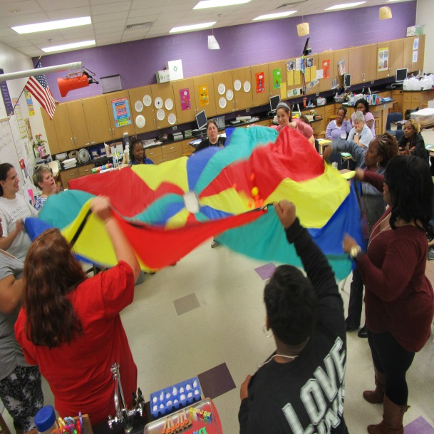

# Training by the Numbers, 2015-16

|  |  |
| --- | --- |
| Total Training Attendance | 304 |
| Child Care Teachers and Directors Served | 51 |
| Number of Training Sessions Offered | 12 |

High-quality child care hinges on high-quality professional development that meets the needs of the local child care workforce.

First Steps-sponsored training is certified through the SC Center for Child Care Career Development and includes topics in the areas of nutrition, health and safety, curriculum, child guidance, professional development and program administration. Best practices in training include not only the training itself, but follow-up in the classroom.

# Program Description

# *Thank you to our partners!*

**CCCC&D**

**Dutchman Creek Middle School**

**Winthrop University and York Technical College**

**Kaplan Learning Materials**

*The Early Childhood conference is always so well organized and the sessions and speakers so informative. I look forward to coming each year.*

Deborah – Child Care Professional



Child Care Scholarships

**Too many families in York County cannot afford quality care for their children.**

# Program Description

**This year, our Scholarship program:**

* **Provided 8 children with a child care voucher so their mother could attend high school**
* **Supported 5 small businesses in York County by subsidizing child care tuition for families who would not otherwise be able to afford quality care**
* **Each Teen Mother received Parents as Teachers Home Visitation Services, in addition to their childcare voucher for quality care for their child while they were in school.**

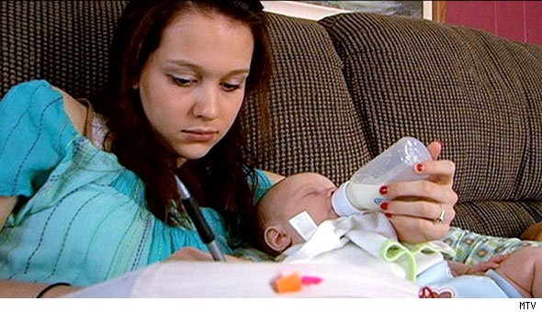

### York County First Steps

410 E. Black St., Rock Hill, SC 29731

Phone – (803) 981-5783

Email - dlisk@rhmail.org

Web Address - www.YCFirstSteps.com

Without my voucher and Home Visits, I would never have been able to finish High School.

Chelsea – Teen Mother

# Scholarships by the Numbers, 2015-16

|  |  |
| --- | --- |
| Children Served | 8 |
| Providers Served | 5 |

**Access to quality child care is essential for children while away from their primary caregivers.** Yet, of those families income-eligible for child care assistance in South Carolina, only a small fraction receive it due to lack of funds. In the absence of nurturing and consistently available family, friends, or neighbors, parents are faced with few - or no – affordable care options.

**York County First Steps serves families in greatest need. Among our scholarship families:**

|  |  |
| --- | --- |
| 100% | **… live in poverty** |
| 100% | **… didn’t graduate from high school** |
| 100% | **… were teen parents** |
| 100% | **… either graduated or were retained in the program** |

In addition to regular monitoring of child care providers that receive First Steps scholarships, First Steps conducts at least one developmental screening each year with scholarship children and connects families to needed services within the community.

All of our Teenage Mothers that received childcare vouchers also received Parents as Teachers Program through their respective school districts.

# *Thank you to our partners!*

**York, Clover, Rock Hill, and Fort Mill School Districts**

**Sunshine House, Fort Mill Prep, Toddler House, House of Joy, and Kid’s World Childcare Centers**

**Deb Shannon – Rock Hill Parent Educator Extraordinaire**

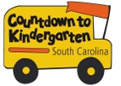

# *CTK by the Numbers, Summer 2015

|  |  |
| --- | --- |
| Children Served | 144 |
| Families Served | 140 |
| Home/School Visits | 838 |

# *\*CTK program data is for June-August 2015, whereas CTK fiscal data includes expenditures from July 1, 2015 through June 30, 2016.*

Countdown to Kindergarten (CTK) is a summer home visitation model connecting rising kindergartners and their families with their future teachers. The program is designed:

* to forge strong and lasting home-school relationships,
* to acquaint children and families with the state and classroom expectations to increase the likelihood of school success,
* to increase parent involvement in the early grades (particularly in hard-to-reach communities), when children’s learning is foundational for life success; and
* to increase public awareness of the importance of school readiness and provide ways for parents and communities to impact children’s early school success.

Countdown to Kindergarten integrates all of the following:

**Home Visitation.** Teachers make six visits over the summer to the homes of participating students and families. Children and families are introduced to actual materials used in kindergarten and are given a Kindergarten Transition Toolkit to keep.

**Learning Celebration.** The last visit is a “field trip” to the school where the child will attend class in the fall.

**Public Awareness.** Throughout the summer, First Steps releases tips to media to help parents and caregivers get children ready for kindergarten.

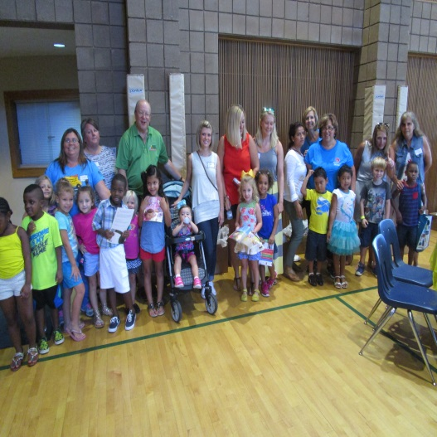

*“I loved the program and my son is so looking forward to starting school. He has a strong attachment to his Kindergarten Teacher and he loves his new books.”*

Margareta – CTK Mother

Countdown to Kindergarten

**Bringing parents and teachers together as partners sets the foundation for success in school.**

**This year, our Countdown to Kindergarten program:**

* **Prior to the CTK Program Home Visits, 73.9 % of our parents read to their child 3 or more times per week. After the CTK Home Visits, 85.3% of our parents read to their child more than 3 times per week with over 25% reading daily.**
* **Prior to the CTK Program Home Visits, 43.2% of the rising kindergarten children were excited about going to school. After the CTK Home Visits, this increased to 54.9% with less than 9% of the children expressing any anxiousness about going to school.**
* **After participating in the CTK Program, 10% more of the families indicated that, they would make it a priority to participate in their child’s classroom activities.**

Chi

### York County First Steps

410 E. Black St., Rock Hill, SC 29731

Phone – (803) 981-5783

Email - dlisk@rhmail.org

Web Address - www.YCFirstSteps.com

# Program Description

**The risk factor box underneath is a Table. To add or delete lines, you must Insert or Delete Rows by right-clicking on the appropriate line. This applies to all pages that include a risk factor box.**

**Use data from the Risk Factor Report to find the most compelling statistics for your program.**

**Delete this text box.**

**York, Clover, Rock Hill, and Fort Mill School Districts**

**The United Way of York County**

**The York County Children’s Museum**

**St. John’s UMC**

# *Thank you to our partners!*

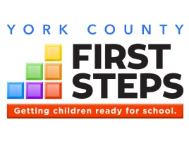

Financial Impact

**Total 2015-16 Expenditures: $498,536**

**State Funds Leveraged in 2015-16*:21%**

**\*Percentage of state dollars matched by additional federal, private, and/or in-kind funds**

*Unaudited numbers for the period July 1, 2015 through June 30, 2016*

**Since inception, York County First Steps has leveraged $4,633,327 from sources outside of state government. That’s 70 cents for every state dollar.**

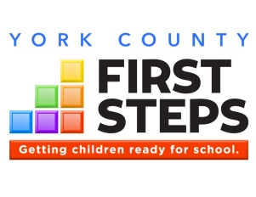

Community Impact

**York County’s Literacy Priority**

Community Partners across the County find new ways to place age appropriate books in the hands of young children!

**Support York County First Steps today through a tax-deductible donation, or volunteer.**

Children learning to read involves much more than having a child sit on your lap for 5-10 minutes while you read a story to them. Literacy based activities can involve having the child tell you a story based on the pictures they see in a book, learning to recognize signs while you ride in the car, or even having a discussion in the kitchen while they help you bake cookies. These activities and many more help reinforce the pre-literacy skills needed for learning to read and establishing a love of reading.

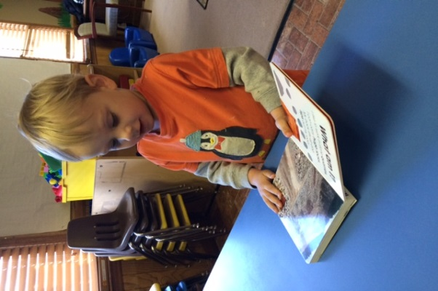In York County, there are a number of organizations, agencies, community, faith, and civic groups working to increase the overall availability of age appropriate books for young children. Each community adapts to their unique needs and determines options that work best for their neighbors. York County First Steps is involved in a variety of ways with our community partners to expand literacy options but we also use these measures to reach the communities we serve to help identify children and families that may need interventions that are more intensive.

Examples of Literacy Collaborations:

* **Cheer for Children Library –** Provides free books through a variety of methods in the Rock Hill School District just for the asking. YCFS has collaborated with Cheer for Children Library to provide needed books to Child Care Centers serving at risk children and to rising kindergarten children.
* **Paradise Reading Center –** Provides an afterschool reading opportunity for preschool to school age children twice week in the Paradise Neighborhood of Fort Mill.
* **Rock Hill Reads –** Citywide effort hosted by the Mayor’s Office to bring Literacy minded groups and individuals to pool ideas and resources to focus attention on the importance of reading in everyone’s life. This forum has helped spread the installation of Little Free Libraries not only in Rock Hill but also around the county and helped bring business leaders to the table to be an integral part of the dialog.
* **The Early Learning Partnership –** This sister agency takes lead on several Literacy focused Programs such as Dolly Parton Imagination Library, Reach Out and Read, and Born to Read.
* **Children’s Museum of York County –** YCFS co-hosts the CTK Celebration for all rising kindergarten children in the County and distributed over 1000 books at the event.



**Launching Nurse-Family Partnership…Finally!**

**The 3rd Community Effort to bring NFP to our Region is successful.**

First Steps Partnership Board

York County First Steps has been involved in all previous efforts to bring Nurse-Family Partnership to our community. After two unsuccessful attempts, perseverance and collaboration provided a path to bring this important program to the Region. The York County First Steps Partnership Board has worked diligently to find the right implementing Agency partner to offer the NFP services to at risk first time mothers. After the two earlier failed attempts to find the right partner, before the Program was passed over once more, the YCFS Board stepped up to apply to be the Implementing Agency for our Region. This was a step of faith in that we would be required to secure the funds on our own and commit to provide these services beyond our County to include Chester and Lancaster Counties.

The step of faith exhibited by the Board has been successful with the strong support of our community partners and our sister First Steps partners in Chester and Lancaster Counties. We have secured sufficient funding for the next 2-3 years and hired our initial team of nurses. We look forward to expanding to our full potential and helping at risk first time mothers for years to come.

|  |  |  |
| --- | --- | --- |
| **Name** | **Position** | **Board Category** |
| **Cindy Hunt, Chair** | **ParentSmart Family Resource Center** | **Appointee – Rock Hill SD #3** |
| **Carol Mann, Vice Chair** | **Retired School Teacher** | **Appointee - Legislative** |
| **Deborah Dukes, Secretary** | **York Technical College Professor** | **Family Education** |
| **Vivian Agurs** | **Smart Kids CDC** | **Faith Community** |
| **Joyce Argo** | **Teacher at Clinton Elementary School** | **Pre-K – Primary School** |
| **Mary Chamberlain** | **Winthrop Makefast CDC** | **Early Childhood Education** |
| **Nina Feemster** | **Bright Beginnings Family Resource Center** | **Appointee – Clover SD #2** |
| **Susan Collier** | **DHEC** | **Appointee - DHEC** |
| **Carol Perkins** | **PITC** | **Early Education** |
| **Jane Culp** | **LEAP Ahead Family Resource Center** | **Appointee - Fort Mill SD #4** |
| **Joy Bower** | **Rock Hill School District** | **Medical** |
| **Penny Sanders** | **Parenting Partners Family Resource Center** | **Appointee – York SD #1** |
| **Mary Watson** | **Winthrop MacFeat CDC** | **Pre-K Primary School** |
| **Diane Williams** | **York County Library** | **Appointee – York County Library** |
| **Beth Cooper** | **Culture and Heritage Museum – Children’s Museum** | **Nonprofit** |
| **Patricia Samuel** | **HeadStart Director** | **Appointee - HeadStart** |
| **Dr. Winslow Shock** | **Chiropractor** | **Business** |
| **Tenisha Powell** | **Winthrop University** | **Early Childhood Education** |
|  |  |  |
|  |  |  |
|  |  |  |
|  |  |  |
|  |  |  |

**York County First Steps Partnership Board, 2015-16**

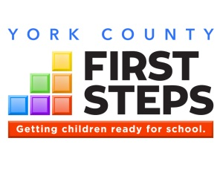

Getting children ready for school.

# The Goals of First Steps

**(1) provide parents with access to the support they might seek and want** to strengthen their families and to promote the optimal development of their preschool children;

**(2)increase comprehensive services** so children have reduced risk for major physical, developmental, and learning problems;

**(3)promote high‑quality preschool programs** that provide a healthy environment that will promote normal growth and development;

**(4)provide services** so all children receive the protection, nutrition, and health care needed to thrive in the early years of life so they arrive at school ready to succeed; and

**(5)mobilize communities** to focus efforts on providing enhanced services to support families and their young children so as to enable every child to reach school healthy and ready to succeed.

-- Section 59‑152‑30



BabyNet in York County:   
LOCAL SPOE PHONE # (803) 222-5360

**http://scfirststeps.org/babynet/**



Interested parents can contact any participating 4K providers to complete an application. To view a list of participating First Steps 4K providers, visit:

**http://scfirststeps.org/4k**

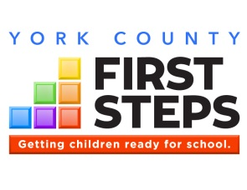

**Funding Support**

State of South Carolina: $412,696  
(*through South Carolina First Steps*)

Sisters of Mercy NC Foundation: $75,000

United Way of York County: $22,000

Springs Close Foundation: $37,500

York County First Steps Board Members

**In-Kind Support**

York School District #1 – NFP Offices

Clover School District #2 – BabyNet Offices

Rock Hill School District #3 – YCFS Offices

**Support York County First Steps today through a tax-deductible donation, or volunteer!**

Thank you donors!



**Sure as Sunlight**

**Dr. Ronald F. Ferguson**

there’s a child in your caring

who may someday cure all cancer

but you’ve got to lay the groundwork

so that it can come to pass.

she’s a child who hasn’t blossomed

so you cannot see her brilliance

but as sure as there is sunlight

she is here now in your class.

I can’t tell you what her name is

Nor her height, nor weight, nor color,

only that she is potentially

a history making lass.

**How your support helps children in York County:**

* **$325 provides a rising kindergarten child with the Countdown to Kindergarten Program for the summer**
* **$10 feeds dinner to low-income families attending a parenting workshop**
* **$500 helps a teenage mother stay in high school with a quality child care voucher for one month**
* **$350 can provide a community or faith based organization with age appropriate books for a literacy program for families with limited access to books**

**HOW TO GIVE: Check out our website:** [**www.YCFirstSteps.com**](http://www.YCFirstSteps.com)

# Save the Date!

* YCFS Annual Meeting and Holiday Gathering – Monday December 12, 2016, 6:00 pm- 7:30 pm
* Early Childhood Conference – Saturday March 25, 2017, 8:00 am- 2:30 pm at Dutchman Creek Middle School
* Countdown to Kindergarten Celebration – Thursday, August 3, 2017, 5:00 pm – 7:00 pm, Rock Hill, SC